 | Hkkjrh; izksS|ksfxdh laLFkku xqokgkVh  Indian Institute of Technology Guwahati  Guwahati 781 039, India

Chairman, Hostel Management Committee

 | Name | Period
 | Name | From | To
 | Dr. Debkumar Chakrabarti, Design | 11/4/2003 | 2006
Chairman, Hostel Affairs Board

Sl. No. | Name | Period
Sl. No. | Name | From | To
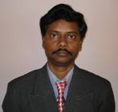 | Dr. Damodar Maity, CE | 18/1/2006 | 17/1/2008
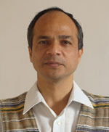 | Dr. Arup Kr. Sarma, CE | 13/6/2007 | 30/6/2008
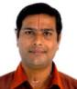 | Dr. K. Pakshiraran, BT | 9/7/2008 | 8/7/2010
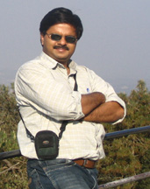 | Dr. S. Ghosh, PH | 9/7/2010
 | Dr. K.V. Krishna, MATHS |  | 30/4/2014
 | Dr. P. Poulose, | 01/5/2014

